CSA1708-ARTIFICIAL INTELLIGENCE
LAB EXPERIMENTS
Program 23 : Prolog Program to Implement Family Tree
Aim
To model family relationships in Prolog and answer relationship queries.
Algorithm
1. Add male, female, and parent facts for family members.
2. Define father and mother rules using the facts.
3. Define grandparent and sibling rules from parent facts.
4. Run queries to check the required family relationships.
Program
male(john).
male(peter).
female(mary).
female(alice).
female(susan).
parent(john, mary).
parent(john, peter).
parent(mary, alice).
parent(peter, susan).
father(X, Y) :- male(X), parent(X, Y).
mother(X, Y) :- female(X), parent(X, Y).
grandparent(X, Z) :- parent(X, Y), parent(Y, Z).
sibling(X, Y) :- parent(P, X), parent(P, Y), X \= Y.
Sample Input
?- mother(mary, alice).
?- grandparent(john, susan).
?- sibling(mary, peter).
Program Execution
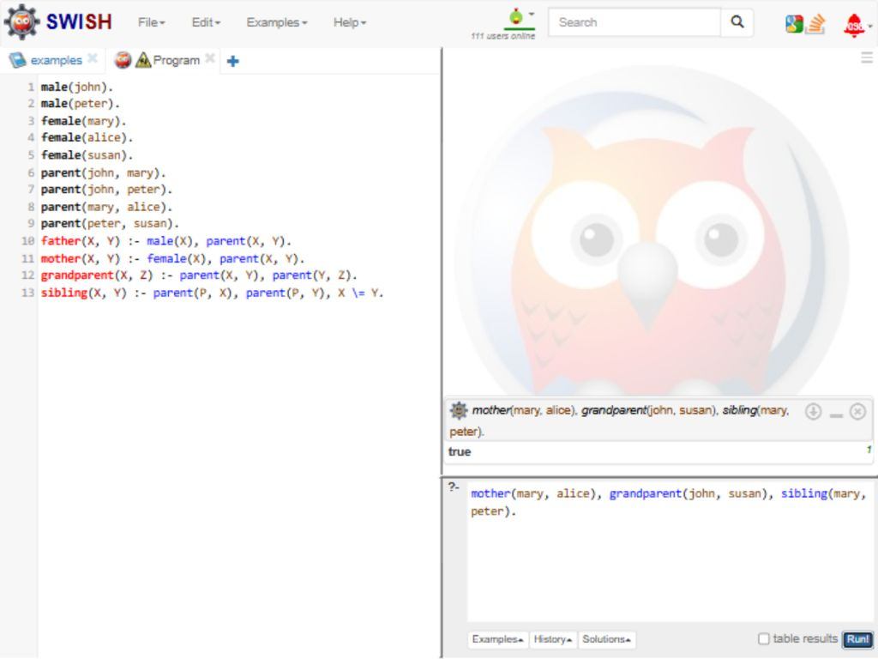
RESULT
Thus, all three family relationship queries returned true.

